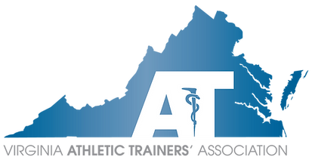

**Call for Applications**

We are currently accepting applications for **Student Affairs Committee Chair** and **Public Relations Committee Chair**.

Application Due Date: March 31, 2025

If you have a desire to work as a team with other athletic trainers that are passionate about promoting our profession across the Commonwealth, please consider submitting an application. One of the best parts of volunteerism with the state association is the opportunity to interact with other professionals.

The Nominations Committee will review if the applicant is eligible and in good standing as per the VATA by-laws. Further information may be requested to verify applicant eligibility. It is ultimately the candidates’ responsibility to ensure all documentation has been received and within the deadline.

**Directions:** Provide a brief profile sketch and answer the questions below. You are limited to a maximum of **1500 characters** per question. All candidates must also provide a CV/resume and evidence of current NATA membership, Virginia Athletic Training Licensure, and BOC certification. Please send your application materials and any questions to VATA President Mike Kotelnicki ([vatapresident@gmail.com](mailto:vatapresident@gmail.com)).

**Committee Chairs**

1. What is your biographical sketch (eg education, work experience, research interests)?
2. Why are you interested in pursuing a leadership role in the VATA?
3. What specific professional and leadership experience do you have that will relate to the duties you will be expected to perform?
4. Explain your ability/plan to dedicate time to the projects and office responsibilities?
5. During your professional career, has your employment been terminated or have you been asked by an employer to resign your position (paid or volunteer)?